HR-300 USER'S MANUAL
An excellent small wind turbine generator system



1.Package Content
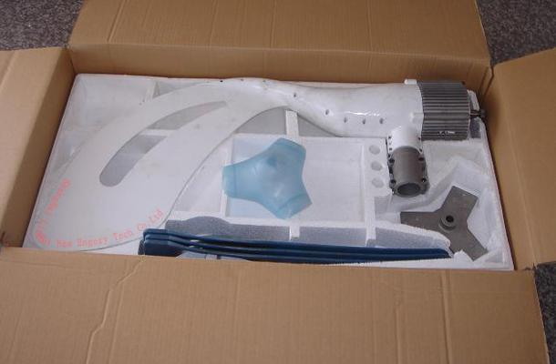
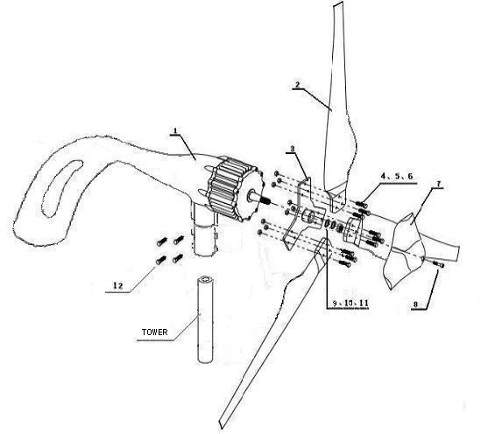
Name and Quantity of Each Components
1 – Generator, tail and flange assembly 1 set
2 - Blades 3 pieces
3 - Flange for blades 1
4, 5, 6 – Bolts, Nuts and Washer 9 sets
7 - Dome 1
8 - Screw 1
9, 10, 11 - Bolts, Nuts and Washer 1 set
12 - Screw 4
13 – Rubber Cover (no displaying) 1

There will be the following if user chooses the tower attachment:
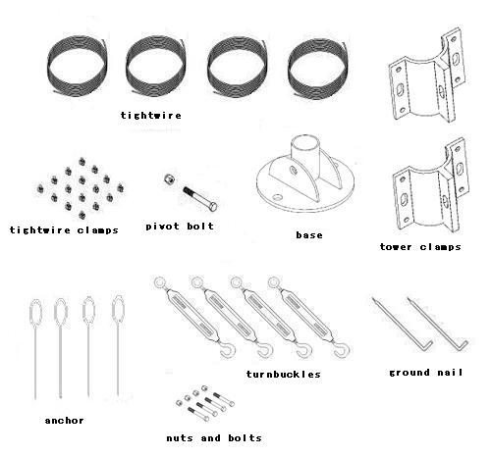
Tower Base 1
Tightwire 4
Tower Clamp 2
Nuts and Bolts 4 set
Tightwire Clamps 16
Pivot Bolt and Nut 1 set
Turnbuckles 4 set
Anchor 4
Nail 2

There will be the following if user chooses the inverter:
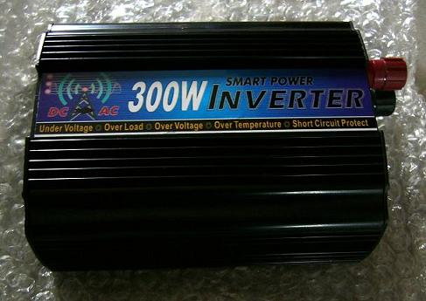
Inverter 1

2. Characteristics
a. Small volume and light weight: The body’s weight is only 12.5kg,and the generator’s volume is only Φ20cm x 20cm.Just two persons can finish the installation.
b. New type blades, tail and shell: The blades and tail 's material is carbon fibre, and the shell of generator 's material is aluminum alloy. They are solid and anti-corrosiveness.
c. Highly compositive electric apparatus: An intelligent controller is included in generator. It has high efficiency and low noise and can unload excrescent charge. This design reduced count of parts and the install workload, and enhanced dependability.

Inner Picture (radiator is voltage controller)
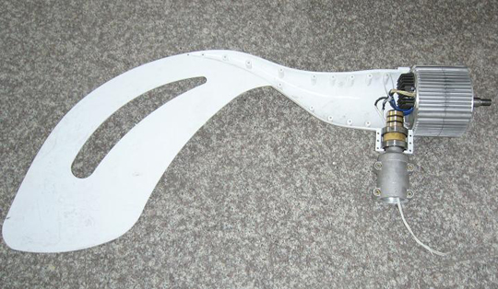
3. Specifications
Model: AEOLUS 300
Rated Power: 300W
Maximum Power: 500W
Wheel Diameter: 1.5m
Start-up Wind Speed: 2.5m/s
Rated Wind Speed: 12m/s
Rated Voltage: 12V/24V/36V/48V
Net Weight: 12.5kg
It can supply about 50kwh per month under the condition: average wind speed is 12m/s per day, valid wind hours is 210h per month

Power Curve
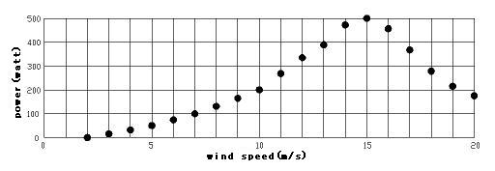
4. Installation
If you want to install the turbine in open space, please follow these steps. We do not supply tower, please prepare a pipe (diameter=48mm, height=6m) by yourself.
Step one. Chose a space to lay the base and anchor like this map.
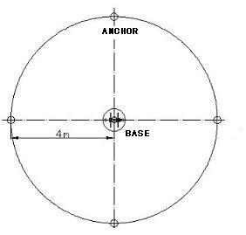
Notes:①You must make sure that one of the base's hatch faces to one anchor.
②Chose a thicker wire if the generator is far from your batteries.
Step two. Use the ground nail to fix base on ground, or use additional Anchor Bolts (not included). Consult the below map.
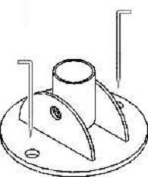
Note: If the ground is loose, please make concrete base for tower base and anchors (depth=500mm, length=400mm).
Step three. Put the foot of tower into the pipe of tower base, and the head on a sawbuck or other wood stuff (height=700mm). Install the tower clamp onto tower (About 1.5m from the top), Tightening bolts. Pull the cable from the hole in tower base into the tower and elicit it on the top, then connect it with generator's out wire, attention to the anode, cathode and earthing. Cover the tie-in of wire with e insulating tape.
Step four. Use rubber cover to ring the top of tower, and then use the generator flange to ring the rubber, and tighten bolts. Then install blades and dome.
Step five. Put four tightwires's ends into the waist holes of tower clamps and lock them by tightwire clamps separately. Connect three of tightwires' other ends to anchors, except the one to the opposite anchor of generator. One person pulls the tower up, another one pull the free tightwire back, till ereck the tower. Then connect the free tightwire to the anchor. The below photo show you how to lock tightwire.
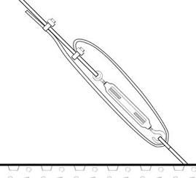
Step six. Adjust turnbuckles. A little loose tightwire is safe than a tight one.
If you want to install it in other environment such as on the streetlights, on house walls, on boards etc, please design a project according to the specific. Please pay attention to that the pipe’s diameter should be 48mm,and there cannot be any obstacles in 800mm below generator's center axis.

5. Laying the batteries and inverter
The battery must be placed in a drying and ventilated room where temperature is constant. Calculate the battery's total number of parallel and serial, and then design the wooden stand for battery and inverter. Series will be battery, the battery first one then the second battery cathode electrode. Followed by accumulation of the required voltage wiring all showed the first part of grease or other corrosion resistant materials.
Notes: proposed battery configuration for this generators is two 12V150AH batteries.

6. Electrical wiring
6.1. Choose wire
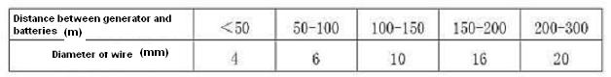

6.2. Electrical wiring maps of off-grid
The ground wire from generator must be connected to earth. The anode wire from generator must connect to batteries’ anode and inverter’s anode. The cathode wire from generator must connect to batteries’ cathode and inverter’s cathode. Must make sure that the generator’s output voltage and batteries’ voltage and inverter’s input voltage is equal, and do not connect an anode to a cathode. A wrong wiring maybe burn the generator or batteries or inverter.
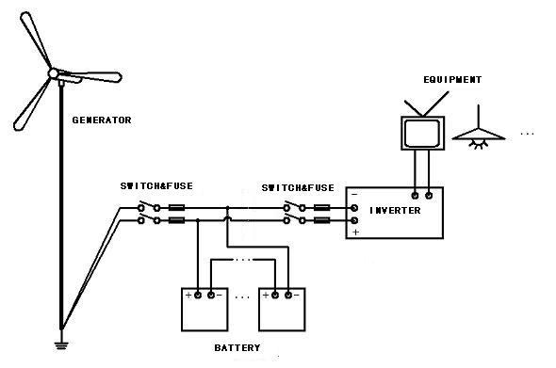
6.3. Electrical wiring maps of on-grid
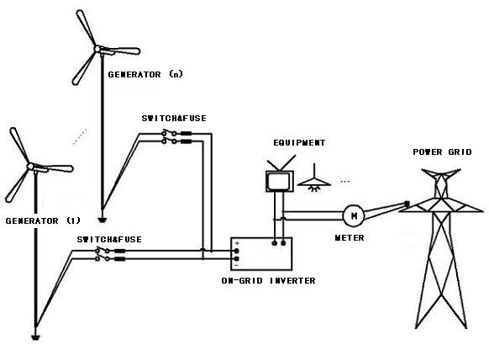
Notes : ① whether the generator can be incorporated into the power grid rests on local laws and regulations .
②On-grid inverter need to be purchased extraly.

7. Maintenance
Do the following check every three months.
7.1. Check the tightwire is too loose or too tight, and adjust them.
7.2. Check whether or not the wire is damaged or loose.
7.3. Maintain the batteries following the battery manual.
PS. We suggest that put down the tower before storm.

8. Familiar questions
Q: Why does not my electro-equipment work after connected to inverter？
A: Check the batteries' voltage. A low voltage will not make electro-equipment work.

Q: Why cannot charge the batteries?
A: Check whether or not the rotor is rolling, the generator have no output at too high or too low wind speed. If the rotor is normal, disconnect the generator's wire from batteries and controller (if there is a individual controller); check the output voltage of generator by a multimeter. If the voltage is normal please check the batteries is ok, otherwise check the wire of generator.

Q: Why does not the rotor roll at a normal wind speed?
A: If the output wire of generator is short, the rotor will not roll, check the generator's wire after disconnected from batteries.

Q: Can I enlarge the batteries' capability?
A: Enlarge the capability of batteries we suggested would make the batteries on half full state and short the life.

Q: Can I adjust the output voltage of generator?
A: No, but you can select the optimum one before purchase.

Q: Can I adjust the output voltage of inverter?
A: No, but you can select the optimum one before purchase.

Q: How long is the generator's life?
A: It’s 15 years normally.
If you have any other questions please contact our company.

* The color of photographs may be different from real objects.
* No notification if the manual modified.
* This product has two years warranty (no damage by man-made or force majeure)

